**ADJACENCY MATRIX AND LIST OF DIRECTED AND UNDIRECTED GRAPH**

**1.)**

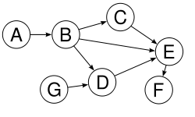

**1.a)**

|  |  |  |  |  |  |  |  |
| --- | --- | --- | --- | --- | --- | --- | --- |
|  | A | B | C | D | E | F | G |
| A | 0 | 1 | 0 | 0 | 0 | 0 | 0 |
| B | 0 | 0 | 1 | 1 | 1 | 0 | 0 |
| C | 0 | 0 | 0 | 0 | 1 | 0 | 0 |
| D | 0 | 0 | 0 | 0 | 1 | 0 | 0 |
| E | 0 | 0 | 0 | 0 | 0 | 1 | 0 |
| F | 0 | 0 | 0 | 0 | 0 | 0 | 0 |
| G | 0 | 0 | 0 | 1 | 0 | 0 | 0 |

**1.b)**

|  |  |  |  |
| --- | --- | --- | --- |
| A | → | B | / |

|  |  |  |  |  |  |  |  |
| --- | --- | --- | --- | --- | --- | --- | --- |
| B | → | C | → | D | → | E | / |

|  |  |  |  |
| --- | --- | --- | --- |
| C | → | E | / |

|  |  |  |  |
| --- | --- | --- | --- |
| D | → | E | / |

|  |  |  |  |
| --- | --- | --- | --- |
| E | → | F | / |

|  |  |  |  |
| --- | --- | --- | --- |
| F | → | / | / |

|  |  |  |  |
| --- | --- | --- | --- |
| G | → | D | / |

**2.)**

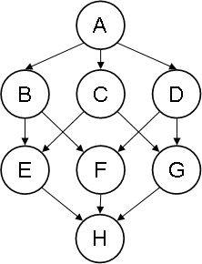

**2.a)**

|  |  |  |  |  |  |  |  |  |
| --- | --- | --- | --- | --- | --- | --- | --- | --- |
|  | **A** | **B** | **C** | **D** | **E** | **F** | **G** | **H** |
| **A** | 0 | 1 | 1 | 1 | 0 | 0 | 0 | 0 |
| **B** | 0 | 0 | 0 | 0 | 1 | 1 | 0 | 0 |
| **C** | 0 | 0 | 0 | 0 | 1 | 0 | 1 | 0 |
| **D** | 0 | 0 | 0 | 0 | 0 | 1 | 1 | 0 |
| **E** | 0 | 0 | 0 | 0 | 0 | 0 | 0 | 1 |
| **F** | 0 | 0 | 0 | 0 | 0 | 0 | 0 | 1 |
| **G** | 0 | 0 | 0 | 0 | 0 | 0 | 0 | 1 |
| **H** | 0 | 0 | 0 | 0 | 0 | 0 | 0 | 0 |

**2.b)**

|  |  |  |  |  |  |  |  |
| --- | --- | --- | --- | --- | --- | --- | --- |
| A | → | B | → | C | → | D | / |

|  |  |  |  |  |  |
| --- | --- | --- | --- | --- | --- |
| B | → | F | → | E | / |

|  |  |  |  |  |  |
| --- | --- | --- | --- | --- | --- |
| C | → | E | → | G | / |

|  |  |  |  |  |  |
| --- | --- | --- | --- | --- | --- |
| D | → | F | → | G | / |

|  |  |  |  |
| --- | --- | --- | --- |
| E | → | H | / |

|  |  |  |  |
| --- | --- | --- | --- |
| F | → | H | / |

|  |  |  |  |
| --- | --- | --- | --- |
| G | → | H | / |

**3.)**

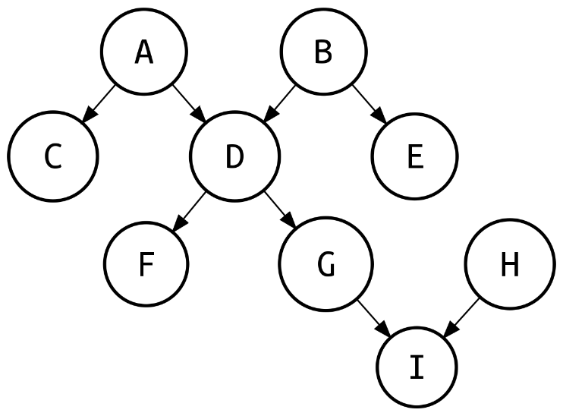

**3.a)**

|  |  |  |  |  |  |  |  |  |  |
| --- | --- | --- | --- | --- | --- | --- | --- | --- | --- |
|  | A | B | C | D | E | F | G | H | I |
| A | 0 | 0 | 1 | 1 | 0 | 0 | 0 | 0 | 0 |
| B | 0 | 0 | 0 | 1 | 1 | 0 | 0 | 0 | 0 |
| C | 0 | 0 | 0 | 0 | 0 | 0 | 0 | 0 | 0 |
| D | 0 | 0 | 0 | 0 | 0 | 1 | 1 | 0 | 0 |
| E | 0 | 0 | 0 | 0 | 0 | 0 | 0 | 0 | 0 |
| F | 0 | 0 | 0 | 0 | 0 | 0 | 0 | 0 | 0 |
| G | 0 | 0 | 0 | 0 | 0 | 0 | 0 | 0 | 1 |
| H | 0 | 0 | 0 | 0 | 0 | 0 | 0 | 0 | 1 |
| I | 0 | 0 | 0 | 0 | 0 | 0 | 0 | 0 | 0 |

**3.b)**

|  |  |  |  |  |  |
| --- | --- | --- | --- | --- | --- |
| A | → | C | → | D | / |

|  |  |  |  |  |  |
| --- | --- | --- | --- | --- | --- |
| B | → | D | → | E | / |

|  |  |  |  |  |  |
| --- | --- | --- | --- | --- | --- |
| D | → | F | → | G | / |

|  |  |  |  |
| --- | --- | --- | --- |
| G | → | I | / |

|  |  |  |  |
| --- | --- | --- | --- |
| H | → | I | / |

**4.)**

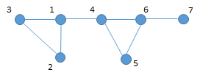

**4.a)**

|  |  |  |  |  |  |  |  |
| --- | --- | --- | --- | --- | --- | --- | --- |
|  | 1 | 2 | 3 | 4 | 5 | 6 | 7 |
| 1 | 0 | 1 | 1 | 1 | 0 | 0 | 0 |
| 2 | 1 | 0 | 1 | 0 | 0 | 0 | 0 |
| 3 | 1 | 1 | 0 | 0 | 0 | 0 | 0 |
| 4 | 1 | 0 | 0 | 0 | 1 | 1 | 0 |
| 5 | 0 | 0 | 0 | 1 | 0 | 1 | 0 |
| 6 | 0 | 0 | 0 | 1 | 1 | 0 | 1 |
| 7 | 0 | 0 | 0 | 0 | 0 | 1 | 0 |

**4.b)**

|  |  |  |  |  |  |  |  |
| --- | --- | --- | --- | --- | --- | --- | --- |
| 1 | → | 2 | → | 3 | → | 4 | / |

|  |  |  |  |  |  |
| --- | --- | --- | --- | --- | --- |
| 2 | → | 3 | → | 1 | / |

|  |  |  |  |  |  |
| --- | --- | --- | --- | --- | --- |
| 3 | → | 1 | → | 2 | / |

|  |  |  |  |  |  |  |  |
| --- | --- | --- | --- | --- | --- | --- | --- |
| 4 | → | 1 | → | 5 | → | 6 | / |

|  |  |  |  |  |  |
| --- | --- | --- | --- | --- | --- |
| 5 | → | 4 | → | 6 | / |

|  |  |  |  |  |  |  |  |
| --- | --- | --- | --- | --- | --- | --- | --- |
| 6 | → | 5 | → | 7 | → | 4 | / |

|  |  |  |  |
| --- | --- | --- | --- |
| 7 | → | 6 | / |

**5.)**

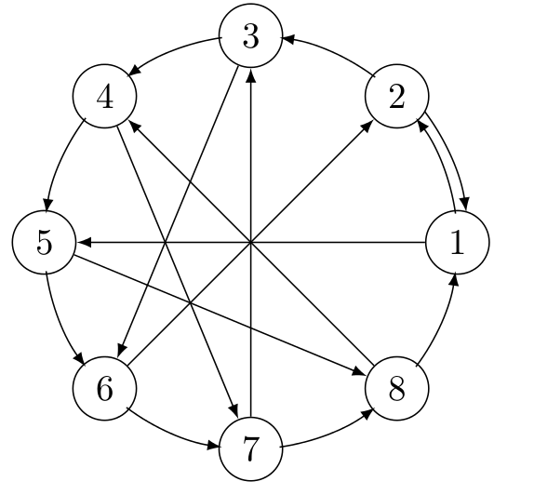

**5.a)**

|  |  |  |  |  |  |  |  |  |
| --- | --- | --- | --- | --- | --- | --- | --- | --- |
|  | **1** | **2** | **3** | **4** | **5** | **6** | **7** | **8** |
| **1** | 0 | 1 | 0 | 0 | 1 | 0 | 0 | 0 |
| **2** | 1 | 0 | 1 | 0 | 0 | 0 | 0 | 0 |
| **3** | 0 | 0 | 0 | 1 | 0 | 1 | 0 | 0 |
| **4** | 0 | 0 | 0 | 0 | 1 | 0 | 1 | 0 |
| **5** | 0 | 0 | 0 | 0 | 0 | 1 | 0 | 1 |
| **6** | 0 | 1 | 0 | 0 | 0 | 0 | 1 | 0 |
| **7** | 0 | 0 | 1 | 0 | 0 | 0 | 0 | 1 |
| **8** | 1 | 0 | 0 | 1 | 0 | 0 | 0 | 0 |

**5.b)**

|  |  |  |  |  |  |
| --- | --- | --- | --- | --- | --- |
| 1 | → | 2 | → | 5 | / |

|  |  |  |  |  |  |
| --- | --- | --- | --- | --- | --- |
| 2 | → | 3 | → | 1 | / |

|  |  |  |  |  |  |
| --- | --- | --- | --- | --- | --- |
| 3 | → | 4 | → | 6 | / |

|  |  |  |  |  |  |
| --- | --- | --- | --- | --- | --- |
| 4 | → | 1 | → | 7 | / |

|  |  |  |  |  |  |
| --- | --- | --- | --- | --- | --- |
| 5 | → | 6 | → | 8 | / |

|  |  |  |  |  |  |
| --- | --- | --- | --- | --- | --- |
| 6 | → | 2 | → | 7 | / |

|  |  |  |  |  |  |
| --- | --- | --- | --- | --- | --- |
| 7 | → | 3 | → | 8 | / |

|  |  |  |  |  |  |
| --- | --- | --- | --- | --- | --- |
| 8 | → | 1 | → | 4 | / |

**6.)**

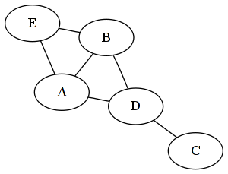

**6.a)**

|  |  |  |  |  |  |
| --- | --- | --- | --- | --- | --- |
|  | A | B | C | D | E |
| A | 0 | 1 | 0 | 1 | 1 |
| B | 1 | 0 | 0 | 1 | 1 |
| C | 0 | 0 | 0 | 1 | 0 |
| D | 1 | 1 | 1 | 0 | 0 |
| E | 1 | 1 | 0 | 0 | 0 |

**6.b)**

|  |  |  |  |  |  |  |  |
| --- | --- | --- | --- | --- | --- | --- | --- |
| A | → | B | → | D | → | E | / |

|  |  |  |  |  |  |  |  |
| --- | --- | --- | --- | --- | --- | --- | --- |
| B | → | A | → | D | → | E | / |

|  |  |  |  |
| --- | --- | --- | --- |
| C | → | D | / |

|  |  |  |  |  |  |  |  |
| --- | --- | --- | --- | --- | --- | --- | --- |
| D | → | A | → | B | → | C | / |

|  |  |  |  |  |  |
| --- | --- | --- | --- | --- | --- |
| E | → | A | → | B | / |

**7.)**

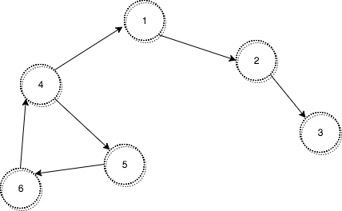

**7.a)**

|  |  |  |  |  |  |  |
| --- | --- | --- | --- | --- | --- | --- |
|  | 1 | 2 | 3 | 4 | 5 | 6 |
| 1 | 0 | 1 | 0 | 0 | 0 | 0 |
| 2 | 0 | 0 | 1 | 0 | 0 | 0 |
| 3 | 0 | 0 | 0 | 0 | 0 | 0 |
| 4 | 1 | 0 | 0 | 0 | 1 | 0 |
| 5 | 0 | 0 | 0 | 0 | 0 | 1 |
| 6 | 0 | 0 | 0 | 1 | 0 | 0 |

**7.b)**

|  |  |  |  |
| --- | --- | --- | --- |
| 1 | → | 2 | / |

|  |  |  |  |
| --- | --- | --- | --- |
| 2 | → | 3 | / |

|  |  |  |  |
| --- | --- | --- | --- |
| 3 | → | / | / |

|  |  |  |  |  |  |
| --- | --- | --- | --- | --- | --- |
| 4 | → | 1 | → | 5 | / |

|  |  |  |  |
| --- | --- | --- | --- |
| 5 | → | 6 | / |

|  |  |  |  |
| --- | --- | --- | --- |
| 6 | → | 4 | / |

**8.)**

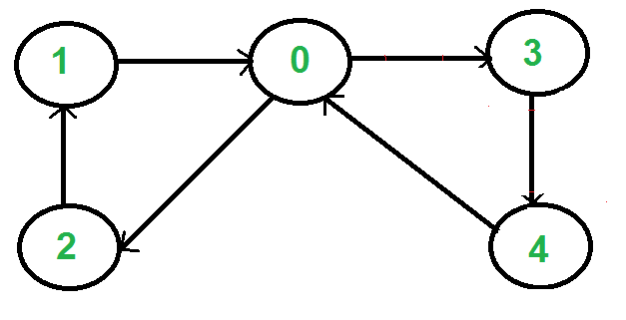

**8.a)**

|  |  |  |  |  |  |
| --- | --- | --- | --- | --- | --- |
|  | 0 | 1 | 2 | 3 | 4 |
| 0 | 0 | 0 | 1 | 1 | 0 |
| 1 | 0 | 0 | 0 | 0 | 0 |
| 2 | 0 | 1 | 0 | 0 | 0 |
| 3 | 0 | 0 | 0 | 0 | 1 |
| 4 | 1 | 0 | 0 | 0 | 0 |

**8.b)**

|  |  |  |  |  |  |
| --- | --- | --- | --- | --- | --- |
| 0 | → | 2 | → | 3 | / |

|  |  |  |  |
| --- | --- | --- | --- |
| 1 | → | / | / |

|  |  |  |  |
| --- | --- | --- | --- |
| 2 | → | 1 | / |

|  |  |  |  |
| --- | --- | --- | --- |
| 3 | → | 4 | / |

|  |  |  |  |
| --- | --- | --- | --- |
| 4 | → | 1 | / |

9)

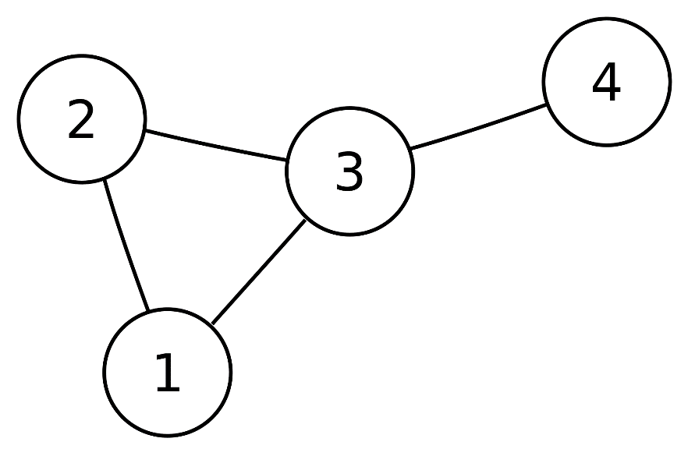

|  |  |  |  |  |
| --- | --- | --- | --- | --- |
|  | 1 | 2 | 3 | 4 |
| 1 | 0 | 1 | 1 | 0 |
| 2 | 1 | 0 | 1 | 0 |
| 3 | 1 | 1 | 0 | 1 |
| 4 | 0 | 0 | 1 | 0 |

10.)

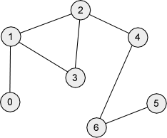1

|  |  |  |  |  |  |  |  |
| --- | --- | --- | --- | --- | --- | --- | --- |
|  | 0 | 1 | 2 | 3 | 4 | 5 | 6 |
| 0 | 0 | 1 | 0 | 0 | 0 | 0 | 0 |
| 1 | 1 | 0 | 1 | 1 | 0 | 0 | 0 |
| 2 | 0 | 1 | 0 | 1 | 1 | 0 | 0 |
| 3 | 0 | 1 | 1 | 0 | 0 | 0 | 0 |
| 4 | 0 | 0 | 1 | 0 | 0 | 0 | 1 |
| 5 | 0 | 0 | 0 | 0 | 0 | 0 | 1 |
| 6 | 0 | 0 | 0 | 0 | 1 | 1 | 0 |

11.)

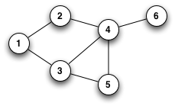

|  |  |  |  |  |  |  |
| --- | --- | --- | --- | --- | --- | --- |
|  | 1 | 2 | 3 | 4 | 5 | 6 |
| 1 | 0 | 1 | 1 | 0 | 0 | 0 |
| 2 | 1 | 0 | 0 | 1 | 0 | 0 |
| 3 | 1 | 0 | 0 | 1 | 1 | 0 |
| 4 | 0 | 1 | 1 | 0 | 1 | 1 |
| 5 | 0 | 0 | 1 | 1 | 0 | 0 |
| 6 | 0 | 0 | 0 | 1 | 0 | 0 |

12.)

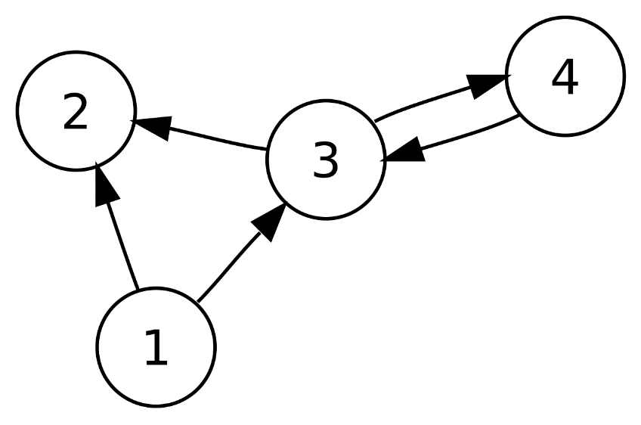

|  |  |  |  |  |
| --- | --- | --- | --- | --- |
|  | 1 | 2 | 3 | 4 |
| 1 | 0 | 1 | 1 | 0 |
| 2 | 0 | 0 | 0 | 0 |
| 3 | 0 | 1 | 0 | 1 |
| 4 | 0 | 0 | 1 | 0 |

13.)

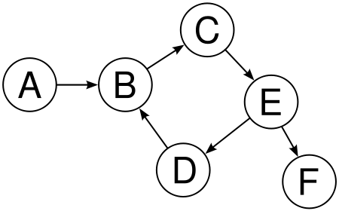

|  |  |  |  |  |  |  |
| --- | --- | --- | --- | --- | --- | --- |
|  | A | B | C | D | E | F |
| A | 0 | 1 | 0 | 0 | 0 | 0 |
| B | 0 | 0 | 1 | 0 | 0 | 0 |
| C | 0 | 0 | 0 | 0 | 1 | 0 |
| D | 0 | 1 | 0 | 0 | 0 | 0 |
| E | 0 | 0 | 0 | 1 | 0 | 1 |
| F | 0 | 0 | 0 | 0 | 0 | 0 |